Store Layout Project Rubric

Article Highlights | Provided article must be highlighted. Only highlight key words! | 1 | 2 | 3 or 4 | 5
Floor Plan Blueprint  (Can be done by hand or computer) | All items must be labelled.  Floor plan must include  - storage area  - checkout counter  Additional items are up to you but they must be labelled. Refer to example below. Floor plans must be completed neatly and with a ruler if by created by hand. | 1 | 2 | 3 or 4 | 5
Report | Your report must answer the list of questions provided in detail. | 1 | 2 | 3 or 4 | 5
Presentation | A 2-3 minute presentation explaining how you set up your retail store, how it works and why. Full marks are given if your dress code matches the theme of your store. | 1 | 2 | 3 or 4 | 5
Model | Create a model that represents your retail store layout in a shoe box. | 1 to 3 | 4 to 6 | 7 to 9 | 10
Total |  | /30

Important Information
- Although marks will not be awarded for scale, both your drawings and model should be fairly realistic. For example, the shelving units in your store cannot be taller than the ceiling.
- There needs to be enough detail in both your drawing and shoe box design to show how your retail store will be set-up
- Use any type of materials necessary to create your model successfully. Your group can use cardboard, paper, modeling clay, paint, miniature models, etc. Keep in mind, you will be awarded marks for effort and the visual effects of the model
- Refer to the class notes on store layout design. You can also research online for more information and inspiration.
Floor Plan Example
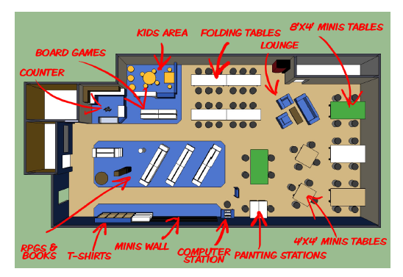

Use ruler for the lines

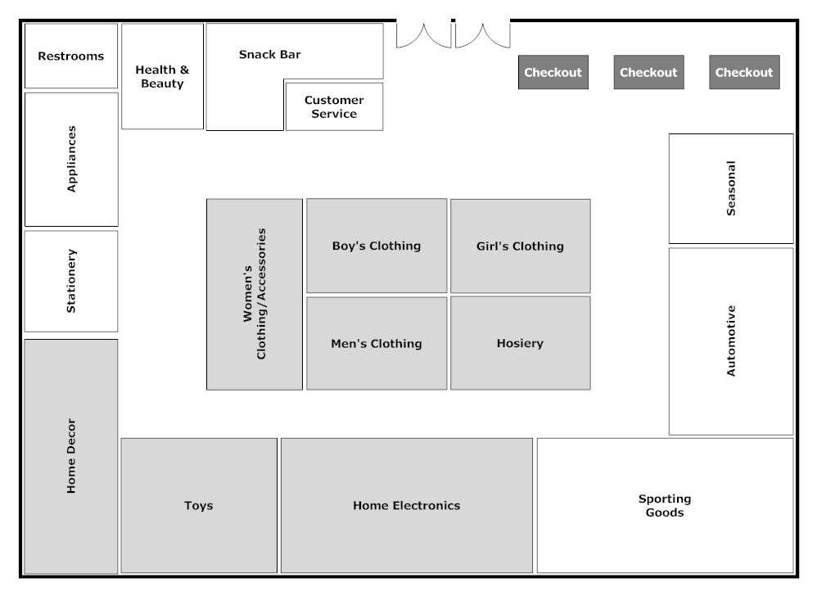

Report Questions
- What is your store name? How does the name relate to your store/brand?

- What type of retail store are you opening (grocery, clothing, sporting goods, etc.)?

- What is your target market and why (include target market sections!!)?
  - Groups could be: high school students, teenagers, young parents, Asians, elderly, high-income professionals, etc.

- What layout are you using and why?

- What is the theme or focus of your design?

- Explain how your layout and design is going to work
  - Example:
    - how should they be moving through the store
    - how it encourages longer shop times and browsing
    - how does it feature your merchandise
    - any additional design ideas that you implemented into the design

